A Secure Full Stack Voting System
Deepak V S
Department of Information Technology
Sri Dharmasthala Manjunateshwara College
Ujire, India
23c10@sdmit.in

Vignesha U G
Department of Information Technology
Sri Dharmasthala Manjunateshwara College
Ujire, India
23c61@sdmit.in

Vivek
Department of Information Technology
Sri Dharmasthala Manjunateshwara College
Ujire, India
23c62@sdmit.in

Abstract---- This project proposes a full stack voting system designed to ensure transparency, security, and trust in the electoral process through a combination of modern web technologies and secure backend architecture. The system integrates frontend and backend components to provide a seamless web application as well as android application where eligible voters can securely cast their votes. The backend handles authentication, vote encryption, and secure storage using databases and server-side logic, ensuring that votes are tamper-proof and cannot be manipulated. Voter anonymity is maintained through secure protocols, while access control ensures that only authorized voters can participate.

Keywords: Full stack voting system, Secure storage, secure, Authentication, Secure protocols.

- INTRODUCTION
This project is a secure and user-friendly online platform designed to conduct elections with high standards of transparency, privacy, and integrity. It features a strong admin authentication system to ensure that only authorized officials can access the backend, manage election settings, oversee candidate details, and monitor the entire voting process. The system enables voters to securely cast their votes online while maintaining confidentiality through encrypted data storage and secure transmission protocols. It provides a smooth and intuitive interface for both administrators and voters, ensuring a hassle-free voting experience. With its robust security structure, efficient vote management, and automated result generation, the platform delivers a reliable, fair, and tamper-proof electronic voting solution. Furthermore, the platform is designed with scalability
and flexibility in mind, allowing it to be adapted for various types of elections such as college elections, organizational polls, and community decision-making processes.

- LITERATURE REVIEW
Several studies have explored technologies to enhance security in web-based voting systems. Golle (2008) highlights the integration of CAPTCHA as an effective tool to prevent automated bot attacks, emphasizing its importance in securing online platforms and ensuring only legitimate users can access voting systems.

Prem T J
Department of Information Technology
Sri Dharmasthala Manjunateshwara College
Ujire, India
23c32@sdmit.in

Similarly, Adida (2008) focuses on authentication and security challenges, particularly the role of admin authentication in maintaining electoral integrity. The research underscores the need for combining CAPTCHA with robust authentication protocols and cryptographic techniques to address vulnerabilities, safeguard data, and ensure transparent and secure voting processes.

- METHODOLOGY

The system will be built as a full stack web application, allowing only eligible participants to vote. Server-side logic will be used to validate votes, ensuring they meet eligibility criteria and preventing duplicate voting. The votes will be securely encrypted and stored in a database, ensuring data integrity and protection. The front-end interface will be user-friendly, enabling seamless voter interaction.

- PROPOSED MODEL
The voting module is designed to ensure a seamless and secure voting process. Each voter is authenticated through a unique ID and password before accessing the ballot. CAPTCHA is implemented to prevent automated bots from compromising the system. Once authenticated, voters can securely cast their votes, which are encrypted and stored in the database to maintain confidentiality and integrity. The system ensures that each user can vote only once, preventing duplicate or fraudulent entries. The architecture also includes real-time validation to ensure a smooth voting experience while upholding stringent security protocols.
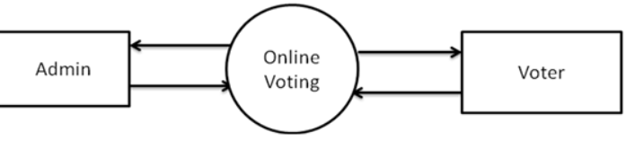
Figure 1: flow chart

4.1 The system flow chart outlines the step-by-step operation of the proposed voting system, starting with user authentication. The flow begins with the voter or admin logging in, verified through credentials and CAPTCHA to block unauthorized or automated access. After successful authentication, voters are directed to the voting interface to cast their vote, while admins access the management panel. Votes are securely encrypted and stored in the database. The flow chart highlights key checkpoints, such as eligibility verification, vote submission, and data integrity checks, ensuring a logical and secure workflow from user login to result compilation.

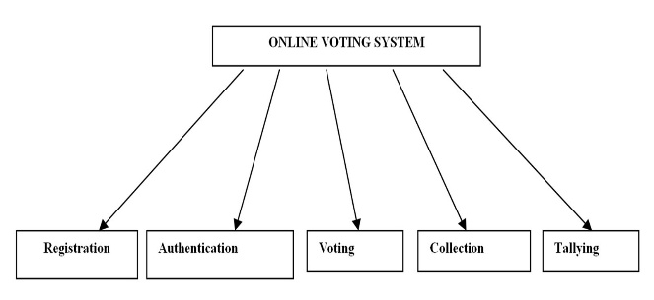
Figure 2: System flow chart

- RESULT
The provided Flask-based web application successfully implements a secure voting system with features like admin authentication, CAPTCHA for bot prevention, and real-time vote casting. After all votes are cast, the system calculates and displays the final results with a dynamic bar chart, highlighting the winner or indicating a tie if applicable. This user-friendly platform ensures a transparent and efficient voting process, while robust security measures maintain the integrity and confidentiality of the election.
5.1 Discussion
This project demonstrates the development of a secure and efficient web-based voting system that incorporates multiple layers of security and user interaction. By integrating CAPTCHA, the system effectively mitigates the risk of automated bot attacks, ensuring that only legitimate users participate in the voting process. Admin authentication serves as a crucial safeguard, granting exclusive access to critical management functions like setting up candidates and viewing results.
The use of session management ensures each vote is tracked correctly while preventing users from voting multiple times. The dynamic CAPTCHA and the password-protected results section reinforce security, preventing unauthorized access at various stages. The design also allows flexibility in setting up the number of candidates and total voters, making the system adaptable for diverse election scenarios. Displaying results with an interactive bar chart not only enhances user experience but also ensures transparency, as all stakeholders can visualize the voting outcome clearly. Moreover, the system highlights the winner dynamically.

- CONCLUSION
The secure web-based voting system developed in this project successfully addresses key challenges in online elections, such as authentication, security, and transparency. By incorporating CAPTCHA, admin authentication, and dynamic vote tracking, the system ensures only legitimate users can participate, and votes are accurately recorded and displayed. The user-friendly interface and real-time results visualization enhance usability and trust in the process. While the system is robust for small to medium-scale elections, integrating database support and advanced encryption can further improve scalability and data security, paving the way for broader adoption in larger electoral scenarios.

- FUTURE SCOPE
The current system provides a secure and efficient platform for small to medium-scale elections, but there is significant scope for enhancement. Future work could focus on integrating a database to store votes and user credentials for improved scalability and persistence. Implementing advanced encryption techniques and blockchain technology could further ensure data integrity and transparency. Multi-factor authentication can enhance security, while accessibility features, such as multi-language support and mobile optimization, can broaden user reach. Additionally, extending the system for remote voting with identity verification through biometric or national ID systems could make it applicable for large-scale, real-world elections.

REFERENCES
- Adida, B. (2008). "Helios: Web-Based Open-Audit Voting." Proceedings of the 17th USENIX Security Symposium, 335-348.
- Rivest, R. L., Smith, W. D. (2007). "Three Voting Protocols: ThreeBallot, VAV, and Twin." Proceedings of the 2007 Electronic Voting Technology Workshop.
- Von Ahn, L., Blum, M., Hopper, N. J., Langford, J. (2003). "CAPTCHA: Using Hard AI Problems for Security." Advances in Cryptology, 294-311.
- Bonneau, J., Herley, C., Van Oorschot, P. C., Stajano, F. (2012). "The Quest to Replace Passwords: A Framework for Comparative Evaluation of Web Authentication Schemes." IEEE Symposium on Security and Privacy, 553-567.
- Bertino, E., Sandhu, R. (2005). "Database Security - Concepts, Approaches, and Challenges." IEEE Transactions on Dependable and Secure Computing, 2(1), 2-19.
- Chaum, D., Ryan, P. Y. A., Schneider, S. (2005). "A Practical Voter-Verifiable Election Scheme." Proceedings of the 10th European Symposium on Research in Computer Security, 118-139.

